1. **INTERPRETING ONE-HOT ENCODED COEFFICIENTS**

That is a much more manageable number of coefficients. Let's go through and interpret these:

* The **\*\*reference category\*\*** for `origin` is `1` (US) and for `make` is `amc` (American Motor Company)

* `const`, `weight`, and `model year` are all still statistically significant

  * When all other predictors are 0, the MPG would be about -18.3

  * For each increase of 1 lb in weight, we see an associated decrease of about 0.006 in MPG

  * For each year newer the vehicle is, we see an associated increase of about 0.75 in MPG

* `origin_2` and `origin_3` are not statistically significant any more

  * While this might seem surprising, our data understanding can explain it. The `origin` feature and the `make` feature are really providing the same information, except that `make` is more granular. Every `make` category (except for `other`) corresponds to exactly one `origin` category. Therefore it probably does not make sense to include both `origin` and `make` in the same model

* At a standard alpha of 0.05, only `make_plymouth`, `make_pontiac`, and `make_volkswagen` are statistically significant

  * When a car's make is `plymouth` compared to `amc`, we see an associated increase of about 2.4 in MPG

  * When a car's make is `pontiac` compared to `amc`, we see an associated increase of about 2.9 in MPG

  * When a car's make is `volkswagen` compared to `amc`, we see an associated increase of about 3.1 in MPG

All of the significant coefficients happen to be positive. Why is that? It turns out that `amc` is the first `make` value alphabetically *_and_* has the lowest mean MPG:

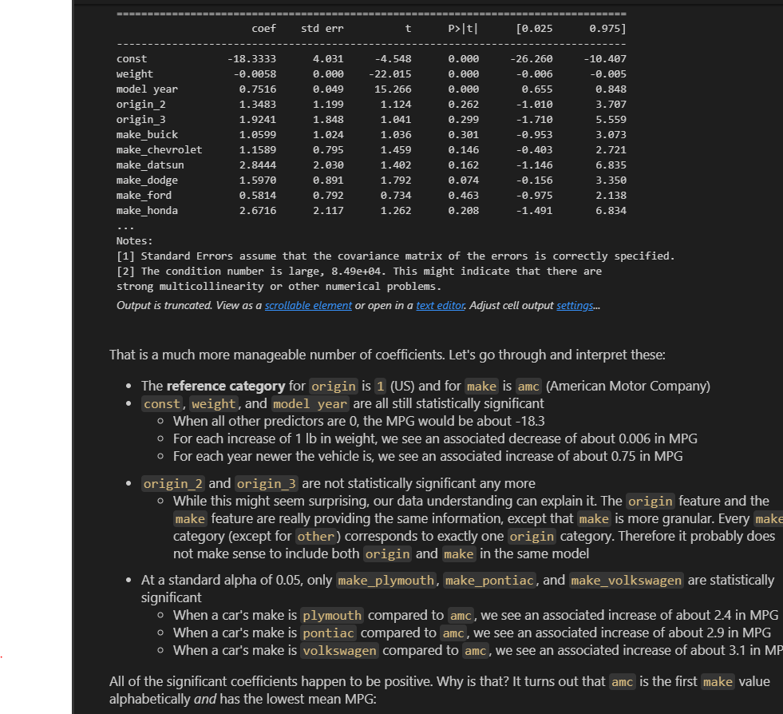

1. **CENTERING**

X_centered = X_initial.copy()

for col in X_centered.columns:

    X_centered[col] = X_centered[col] - X_centered[col].mean()

X_centered.describe()

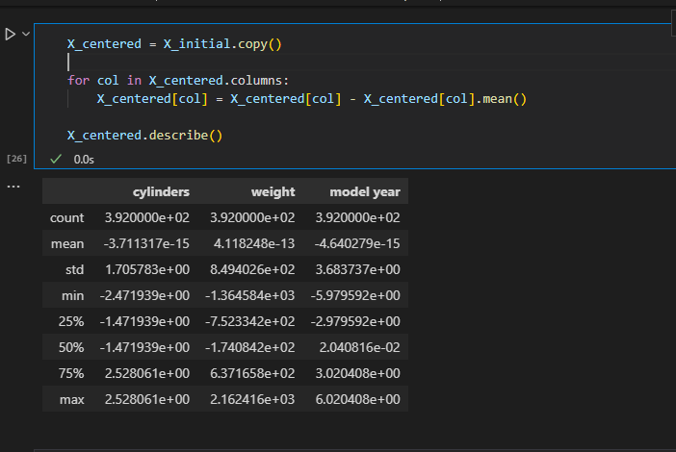

fig, axes = plt.subplots(nrows=3, figsize=(15,15))

for index, col in enumerate(X_initial.columns):

    sns.histplot(data=X_initial, x=col, label="Initial", ax=axes[index])

    sns.histplot(data=X_centered, x=col, label="Centered", color="orange", ax=axes[index])

    axes[index].legend()

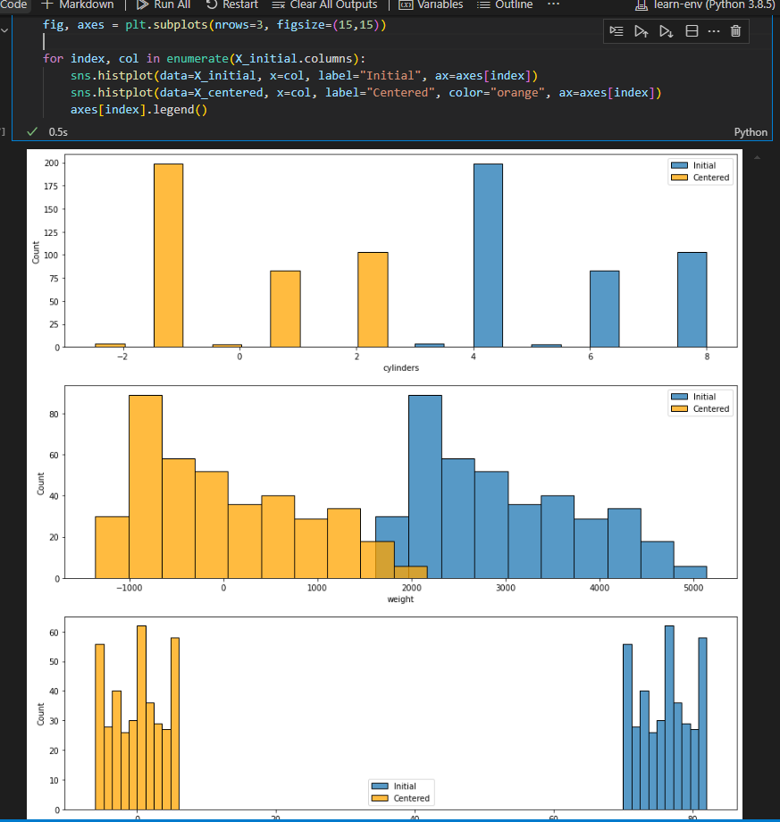

On modelling we can now our coefficients are interpretable

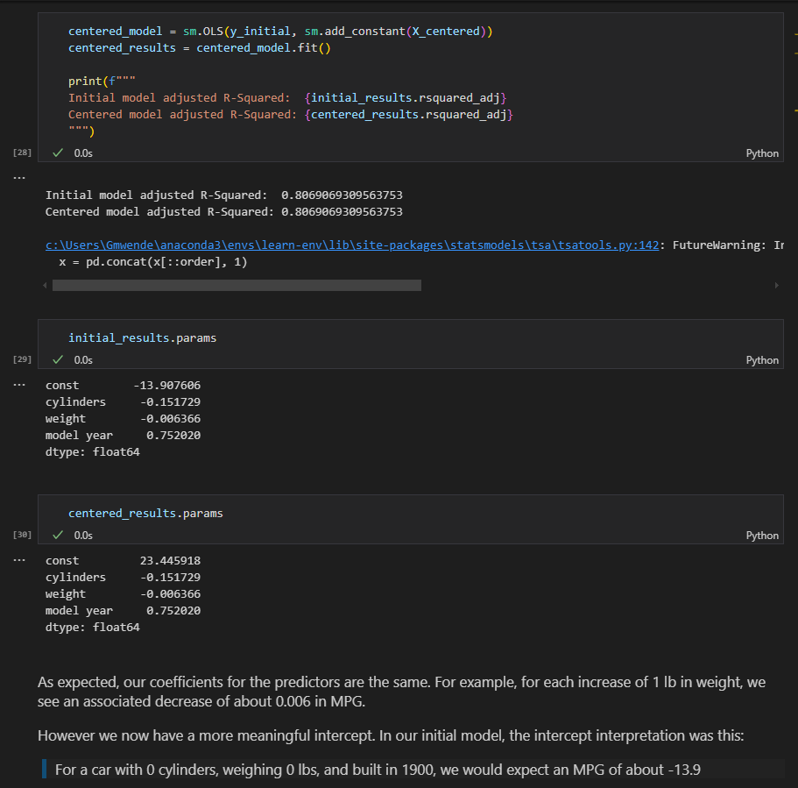

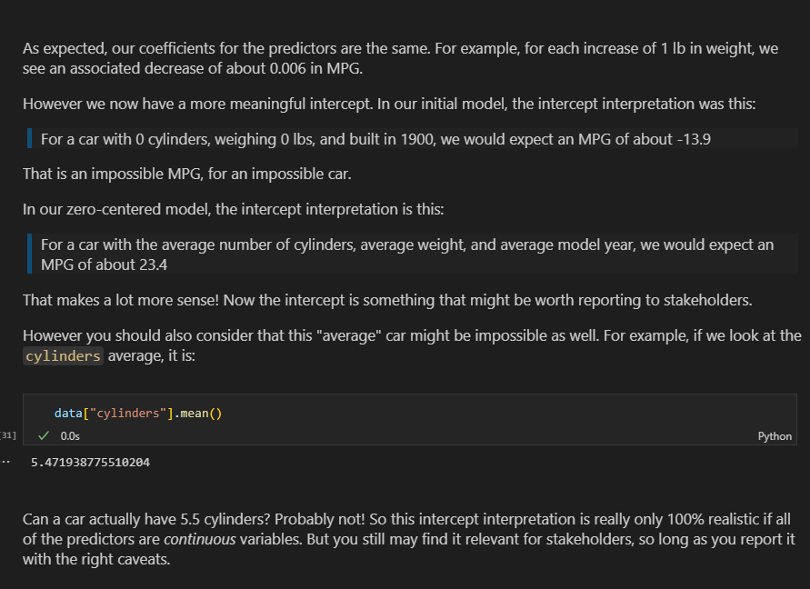

1. Standardization

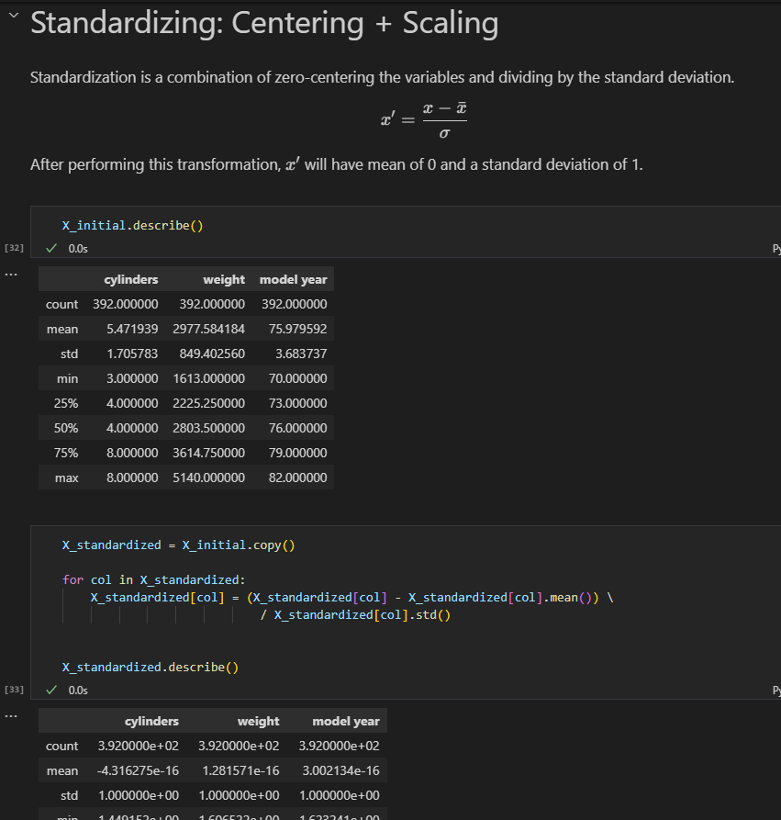

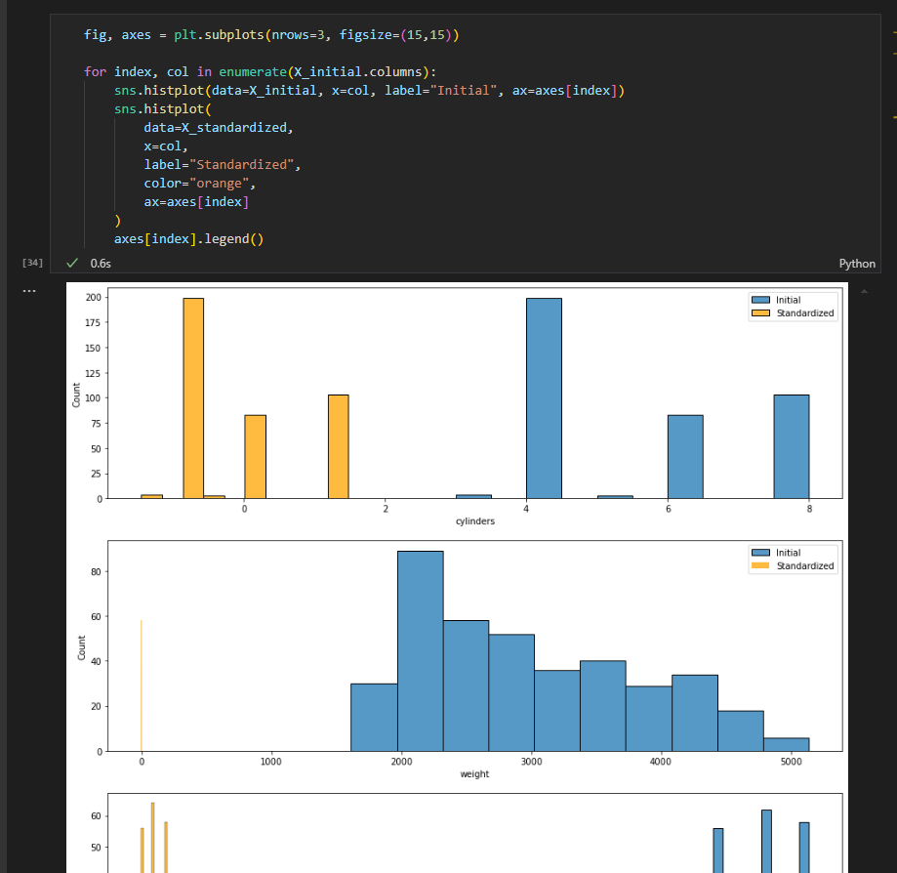

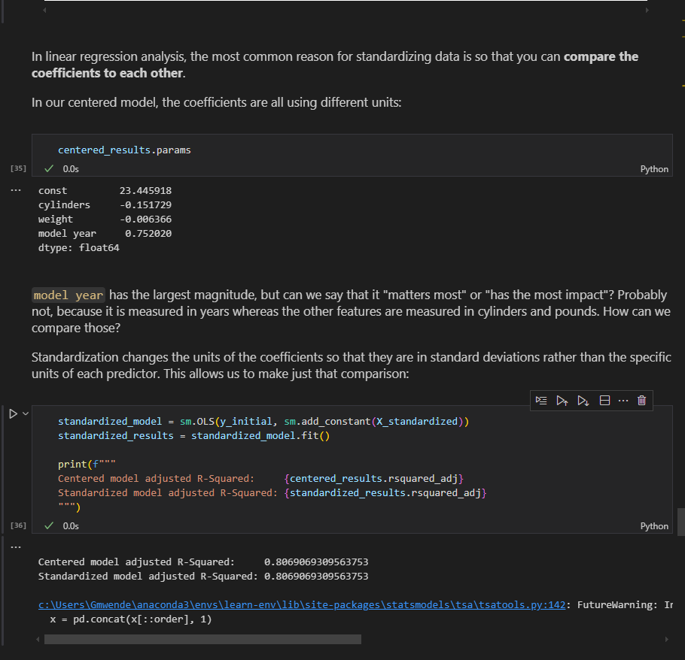

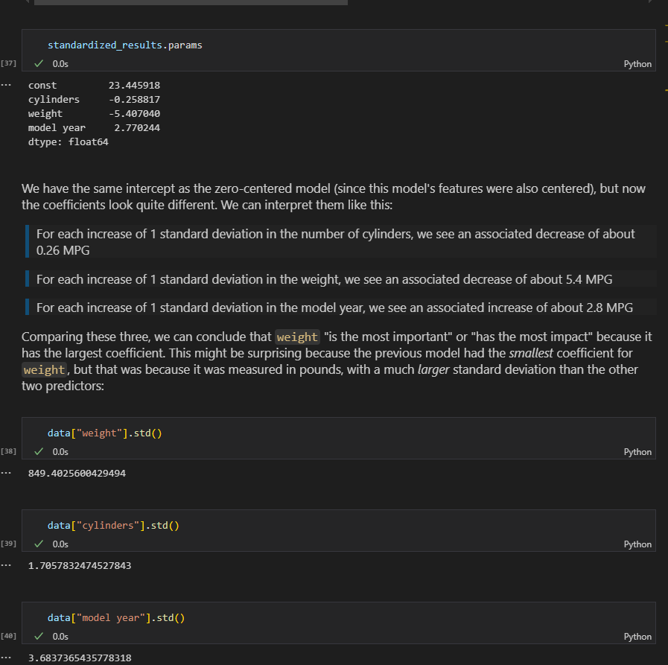

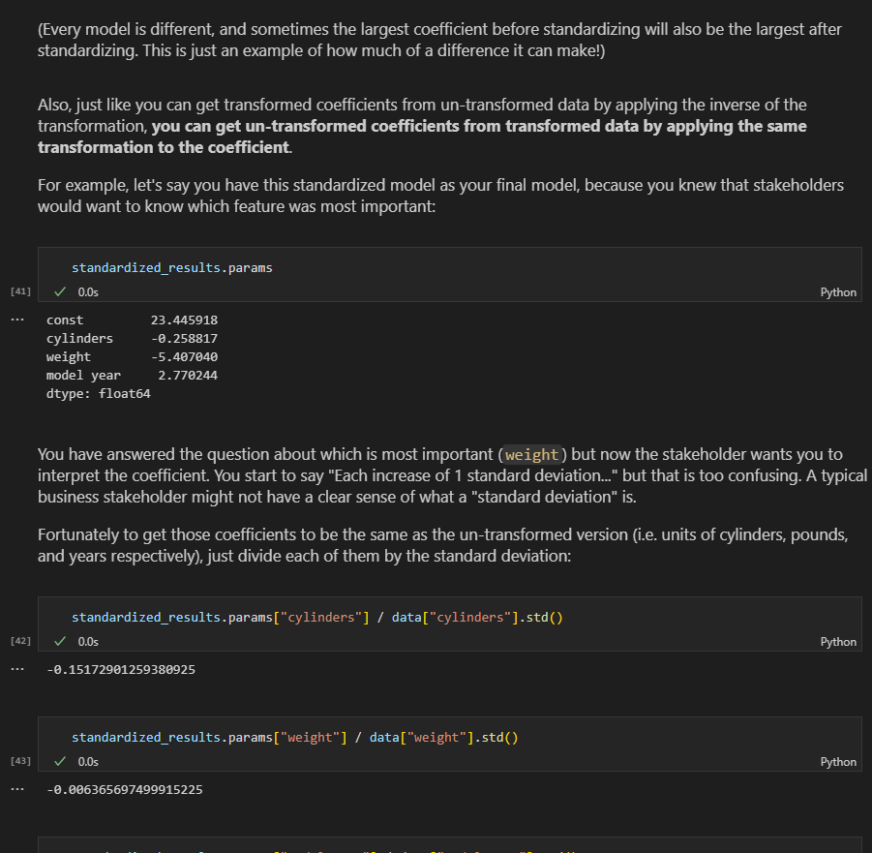

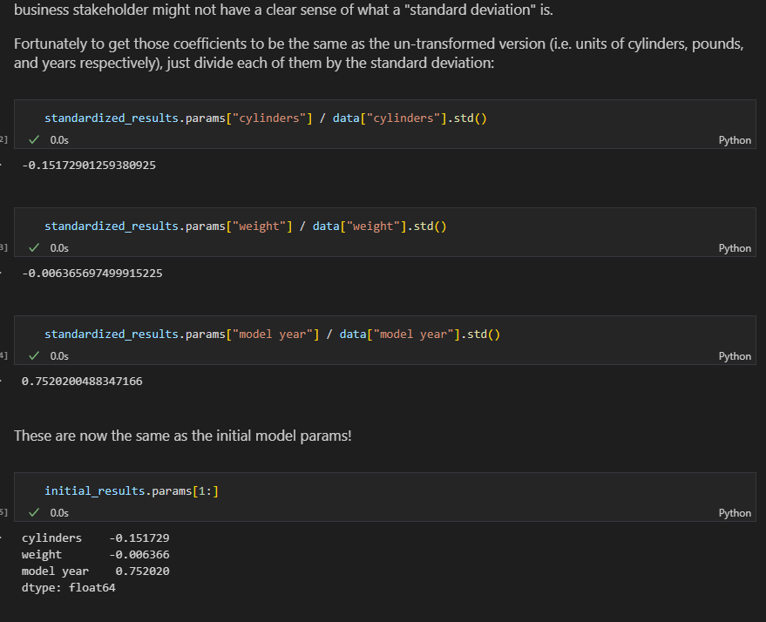

Standardization using sklearn(Standard Scaler)

from sklearn.preprocessing import StandardScaler

scaler = StandardScaler()

x_sk_standarized = scaler.fit_transform(X_initial)

standardized_model2 = sm.OLS(y_initial, sm.add_constant(x_sk_standarized))

standardized_results2 = standardized_model2.fit()

standardized_results2.summary()

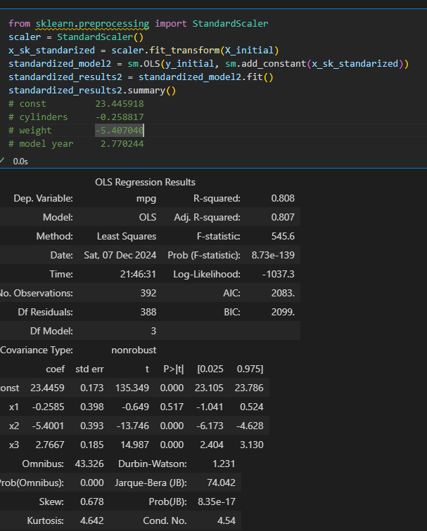

**Draw Graph for multiple columns eg check good candidate for log transformation**

# Run this cell without changes

import matplotlib.pyplot as plt

import numpy as np

y = ames["SalePrice"]

X = ames.drop("SalePrice", axis=1)

fig, axes = plt.subplots(nrows=6, ncols=6, figsize=(15,15), sharey=True)

for i, column in enumerate(X.columns):

    # Locate applicable axes

    row = i // 6

    col = i % 6

    ax = axes[row][col]

    # Plot feature vs. y and label axes

    ax.scatter(X[column], y, alpha=0.2)

    ax.set_xlabel(column)

    if col == 0:

        ax.set_ylabel("SalePrice")

fig.tight_layout()

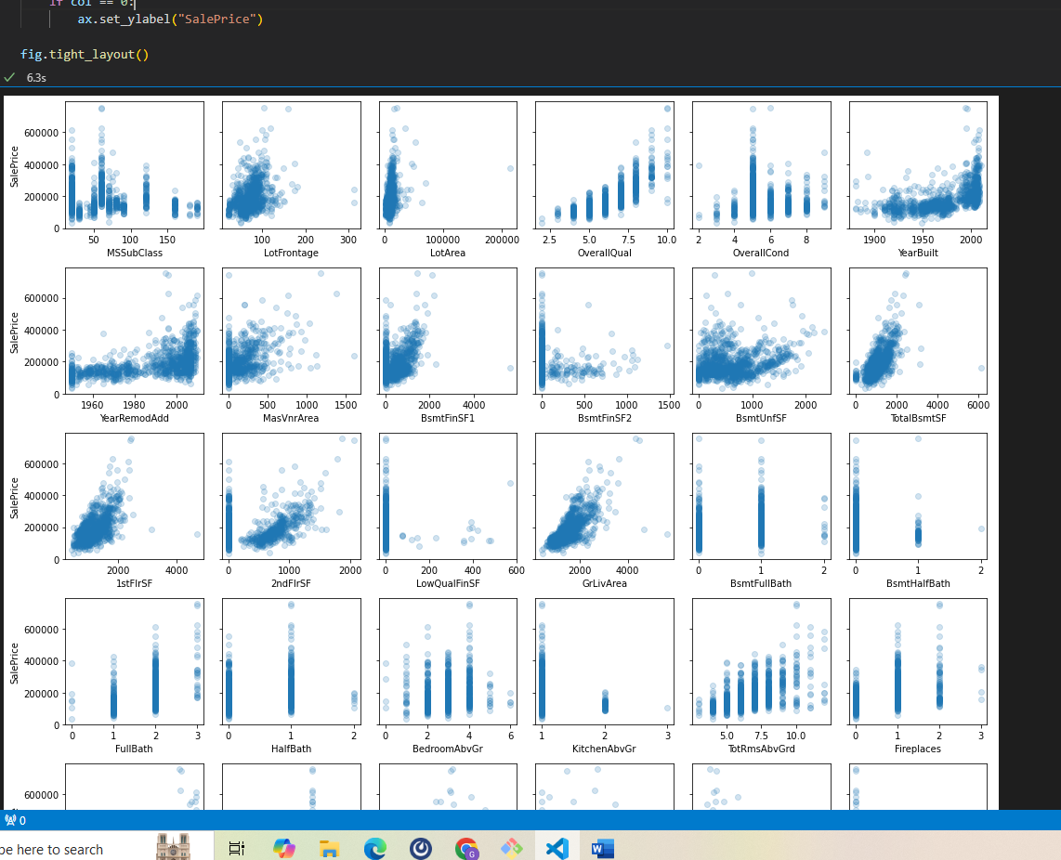

**Log transform Multiple columns**

from sklearn.preprocessing import FunctionTransformer

import numpy as np

# Instantiate a custom transformer for log transformation

log_transformer = FunctionTransformer(np.log, validate=True)

# Columns to be log transformed

log_columns = ['displacement', 'horsepower', 'weight']

# New names for columns after transformation

new_log_columns = ['log_disp', 'log_hp', 'log_wt']

# Log transform the training columns and convert them into a DataFrame

X_train_log = pd.DataFrame(log_transformer.fit_transform(X_train[log_columns]),

                           columns=new_log_columns, index=X_train.index)

X_train_log.head()

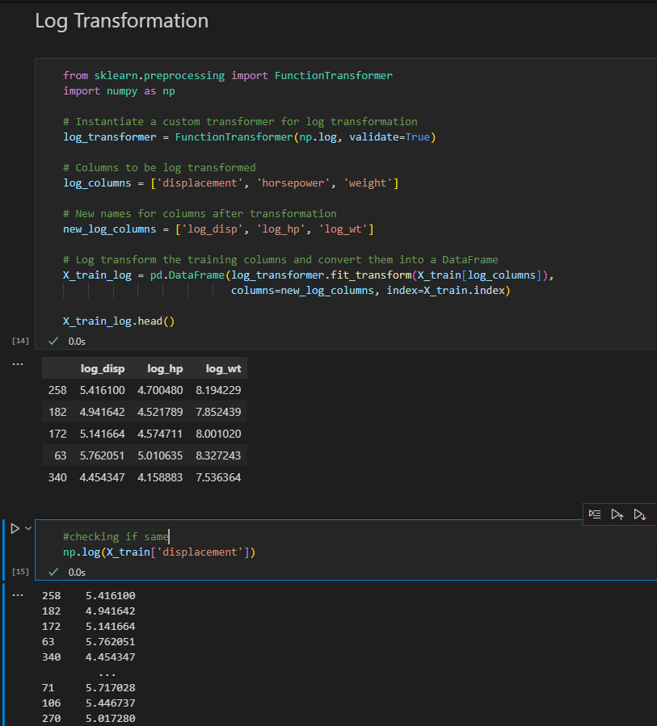

1. **One Hot Encoding using sklearn**

from sklearn.preprocessing import OneHotEncoder

#encode test data

ohe = OneHotEncoder()

columns_to_encode = ['month']

test_encoded = ohe.transform(X_test[columns_to_encode])

#Turn into a dataframe

new_test_df = pd.DataFrame(

              test_encoded.todense(),

              columns= ohe.get_feature_names_out(),

              index=X_test.index

)

new_test_df.head()

#Add year back and drop the month

df_test_concat= pd.concat([X_test,new_test_df],axis=1).drop('month',axis=1)

df_test_concat.head()

#Model score on Test

lr.score(df_test_concat,y_test)

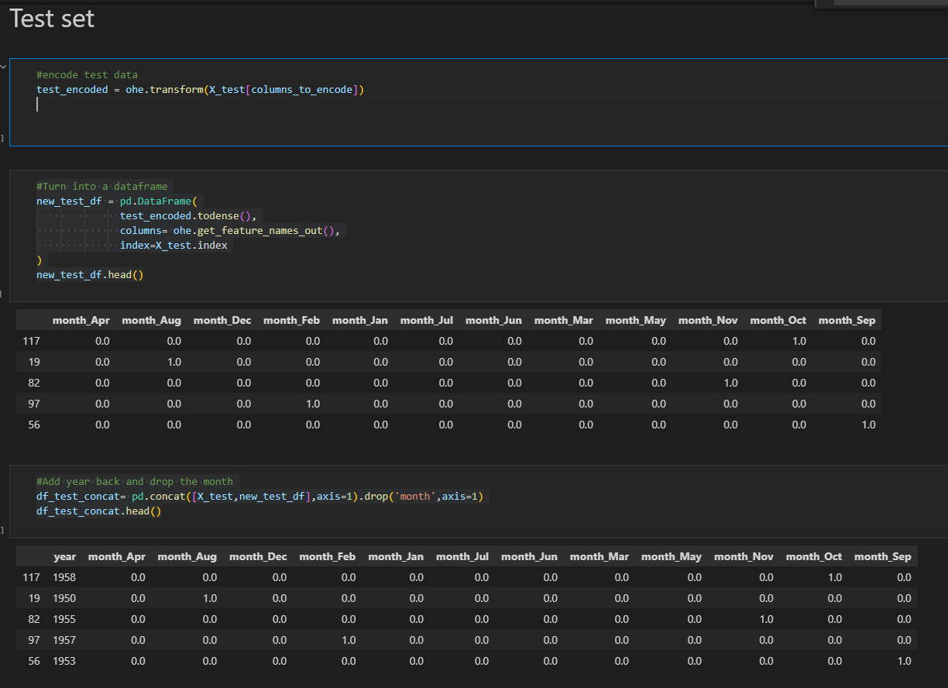

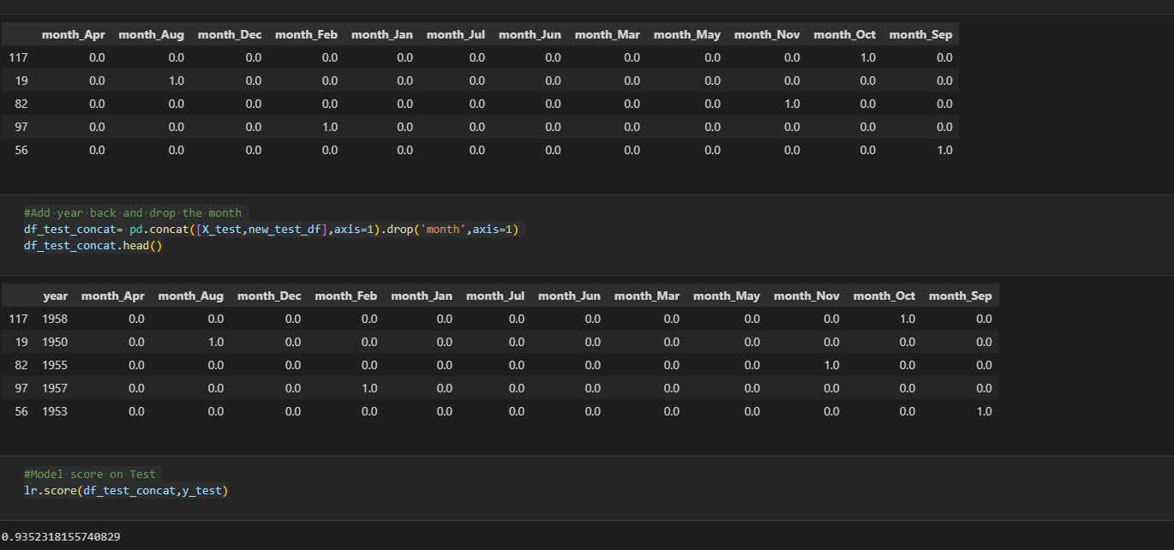

**ONE-HOT ENCODING 2**

from sklearn.preprocessing import OneHotEncoder

# Instantiate OneHotEncoder

# Need to use sparse_output=False for sklearn 1.2 or greater

ohe = OneHotEncoder(drop='first', sparse=False)

# Create X_cat which contains only the categorical variables

cat_columns = ['origin']

X_train_cat = X_train.loc[:, cat_columns]

# Transform training set

X_train_ohe = pd.DataFrame(ohe.fit_transform(X_train_cat),

                           index=X_train.index)

X_train_ohe.head()

# Drop transformed columns

cols_to_drop = log_columns + cat_columns

X_train = X_train.drop(columns=cols_to_drop)

# Combine the three datasets into training

X_train_tr = pd.concat([X_train, X_train_log, X_train_ohe], axis=1)

X_train_tr.head()

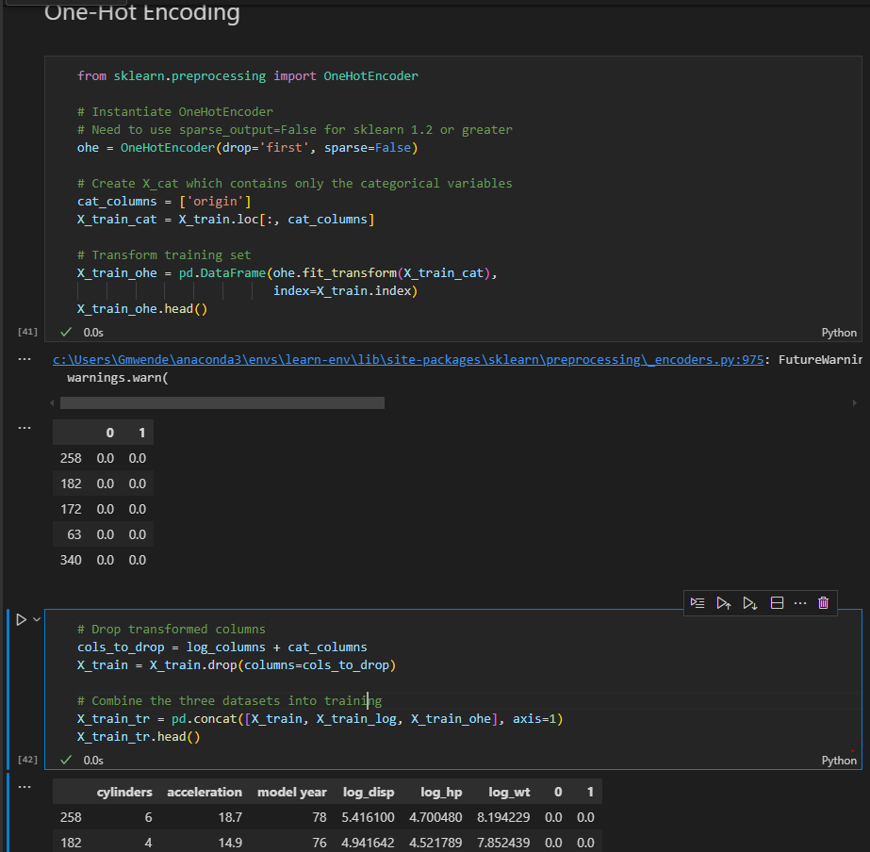

**ENCODE TEST DATA AS WELL**

# Transform testing set

X_test_ohe = pd.DataFrame(ohe.transform(X_test[cat_columns]),

                          index=X_test.index)

X_test_ohe.head()

X_test = X_test.drop(columns=cols_to_drop)

# Combine test set

X_test_tr = pd.concat([X_test, X_test_log, X_test_ohe], axis=1)

X_test_tr.head()

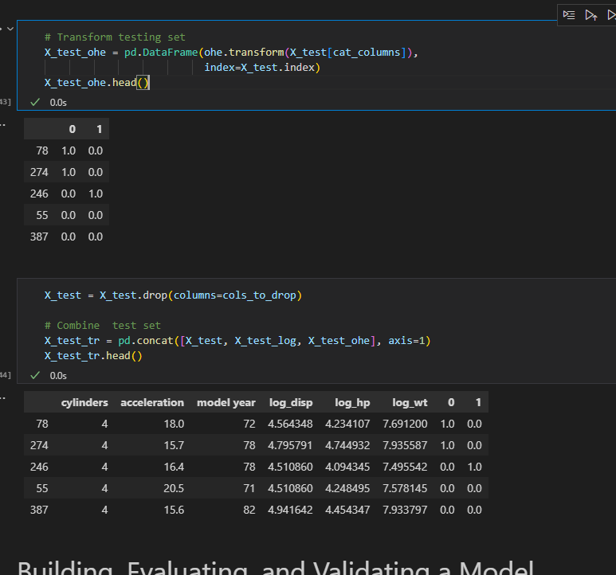

1. **POLYNOMIALS**

from sklearn.preprocessing import PolynomialFeatures

poly = PolynomialFeatures(8)

X_poly_high = poly.fit_transform(x)

X_poly_high

x_poly_high_df = pd.DataFrame(X_poly_high,columns=poly.get_feature_names_out(x.columns),index=x.index)

x_poly_high_df

x_poly_high_df.drop("1",axis=1,inplace=True)

poly_results = sm.OLS(y, x_poly_high_df).fit()

poly_results.summary()

predeictions =  poly_results.predict(x_poly_high_df)

sns.scatterplot(x=df["Temp"],y=df["Yield"])

sns.lineplot(x=df["Temp"],y=predeictions)

plt.show()

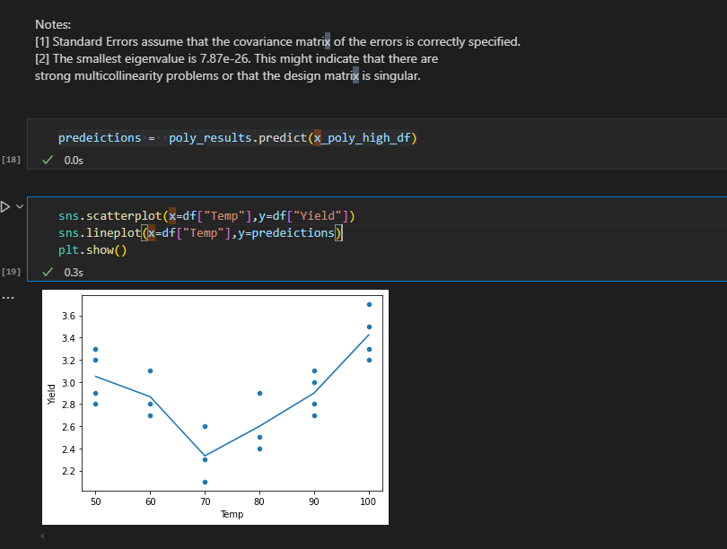

**POLYNOMIAL WITH LINEAR REGRESSION 1**

# 2nd degree polynomial

poly_2 = PolynomialFeatures(2)

reg_poly_2 = LinearRegression().fit(poly_2.fit_transform(X_train), y_train)

fig, axes = plt.subplots(ncols=2, figsize=(13,4), sharey=True)

axes[0].scatter(X_train, y_train, color='green', label="data points")

axes[0].plot(X_linspace, reg_poly_2.predict(poly_2.transform(X_linspace)), label="best fit line")

axes[0].set_xlabel('Temperature')

axes[0].set_ylabel('Yield')

axes[0].set_title('Train')

axes[1].scatter(X_test, y_test, color='green')

axes[1].plot(X_linspace, reg_poly_2.predict(poly_2.transform(X_linspace)))

axes[1].set_xlabel('Temperature')

axes[1].set_title('Test')

fig.legend()

fig.suptitle('2nd Degree Polynomial');

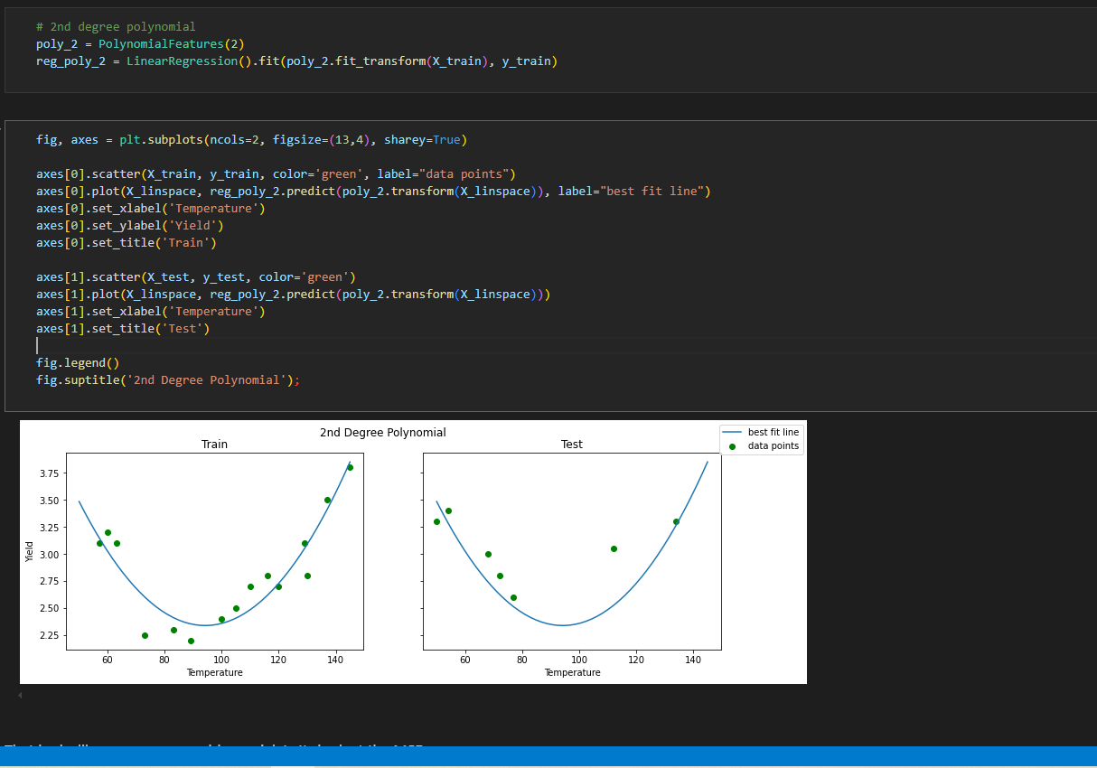

print(f"""

Simple Linear Regression

Train MSE: {mean_squared_error(y_train, reg.predict(X_train))}

Test MSE:  {mean_squared_error(y_test, reg.predict(X_test))}

6th Degree Polynomial

Train MSE: {mean_squared_error(y_train, reg_poly.predict(poly.transform(X_train)))}

Test MSE:  {mean_squared_error(y_test, reg_poly.predict(poly.transform(X_test)))}

2nd Degree Polynomial

Train MSE: {mean_squared_error(y_train, reg_poly_2.predict(poly_2.transform(X_train)))}

Test MSE:  {mean_squared_error(y_test, reg_poly_2.predict(poly_2.transform(X_test)))}

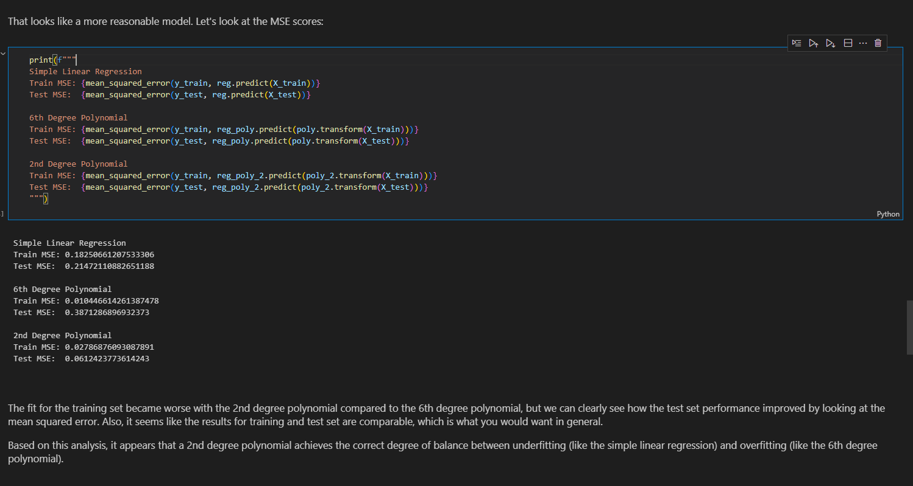

**POLYNOMIAL WITH LINEAR REGRESSION2**

poly = PolynomialFeatures(3)

X_train_poly = poly.fit_transform(X_train_scaled)

X_test_poly = poly.transform(X_test_scaled)

polyreg = LinearRegression()

polyreg.fit(X_train_poly,y_train)

# Training set predictions

poly_train_predictions = polyreg.predict(X_train_poly)

# Test set predictions

poly_test_predictions = polyreg.predict(X_test_poly)

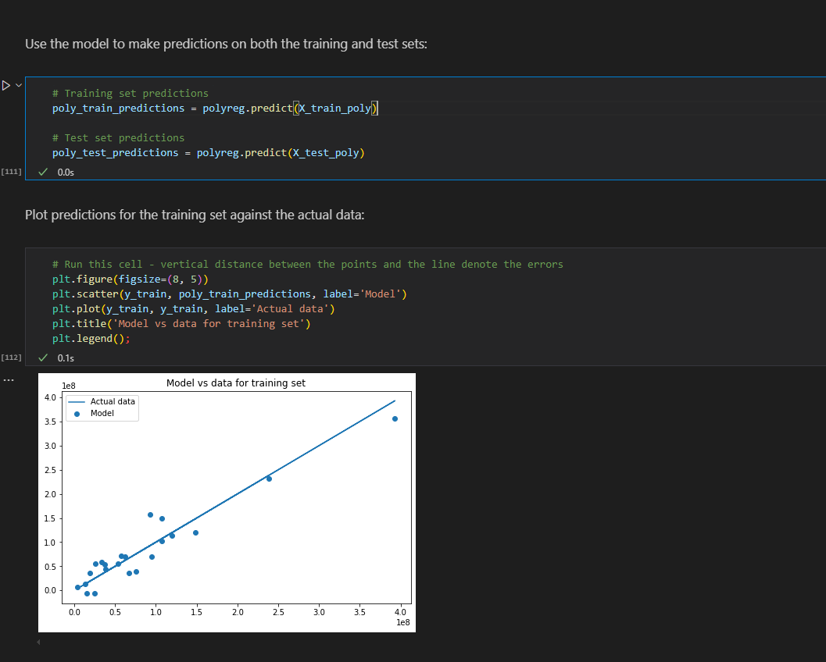

1. **BUILDING,EVALUATING AND VALIDATING A MODEL**

# convert feature names to strings so there is not a TypeError with sklearn

X_train_tr.columns = X_train_tr.columns.astype(str)

X_test_tr.columns = X_test_tr.columns.astype(str)

from sklearn.linear_model import LinearRegression

linreg = LinearRegression()

linreg.fit(X_train_tr, y_train)

y_hat_train = linreg.predict(X_train_tr)

y_hat_test = linreg.predict(X_test_tr)

train_residuals = y_hat_train - y_train

test_residuals = y_hat_test - y_test

from sklearn.metrics import mean_squared_error

train_mse = mean_squared_error(y_train, y_hat_train)

test_mse = mean_squared_error(y_test, y_hat_test)

print('Train Mean Squared Error:', train_mse)

print('Test Mean Squared Error:', test_mse)

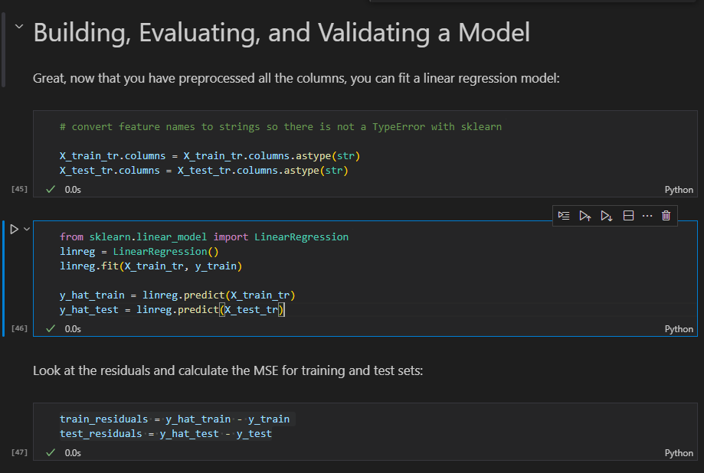

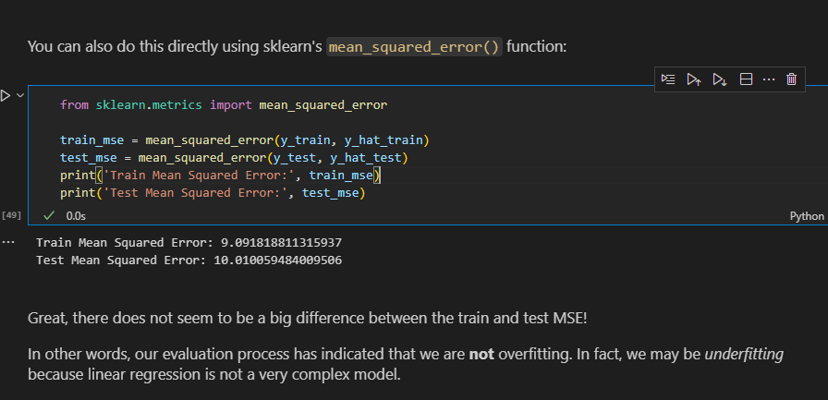

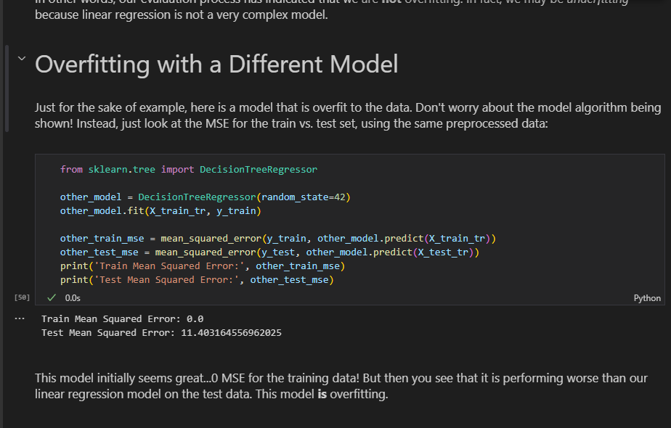

1. **R2 SCORE AND MEAN SQUARED ERROR**

from sklearn.metrics import mean_squared_error, r2_score

  lr = LinearRegression()

    lr.fit(X_train, y_train)

    # Predictions

    y_train_pred = lr.predict(X_train)

    y_test_pred = lr.predict(X_test)

    # Evaluation

    train_mse = mean_squared_error(y_train, y_train_pred)

    test_mse = mean_squared_error(y_test, y_test_pred)

    train_r2 = r2_score(y_train, y_train_pred)

    test_r2 = r2_score(y_test, y_test_pred)

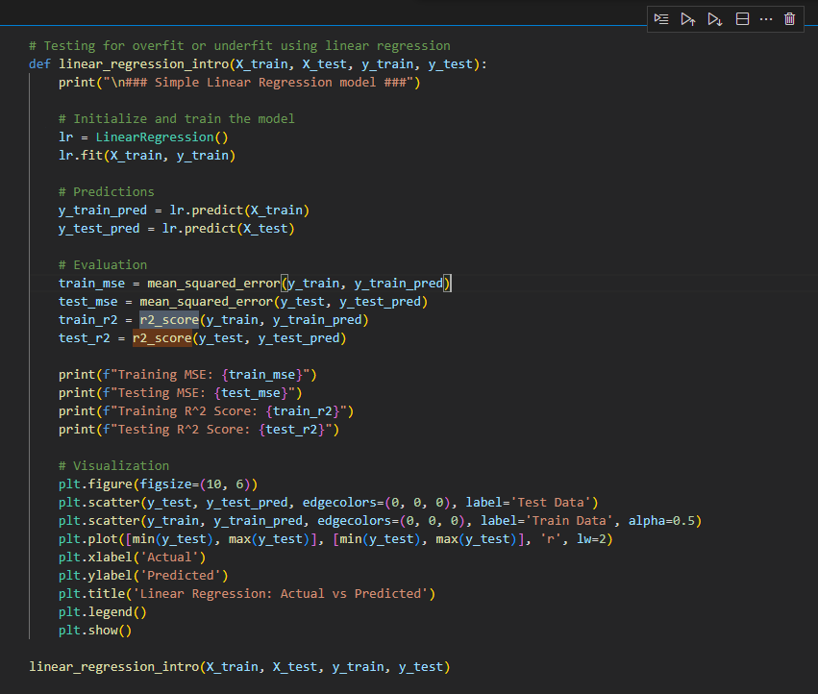

1. **Splitting data**

X = ames.drop('SalePrice',axis=1)

y = ames['SalePrice']

from sklearn.model_selection import train_test_split

X_train,X_test,y_train,y_test = train_test_split(X,y,test_size=0.33,random_state=42)

1. **Log transformation and one hot encoding together**

# Run this cell without changes

from sklearn.preprocessing import FunctionTransformer, OneHotEncoder

continuous = ['LotArea', '1stFlrSF', 'GrLivArea']

categoricals = ['BldgType', 'KitchenQual', 'Street']

# Instantiate transformers

log_transformer = FunctionTransformer(np.log, validate=True)

ohe = OneHotEncoder(drop='first', sparse=False)

# Fit transformers

log_transformer.fit(X_train[continuous])

ohe.fit(X_train[categoricals])

# Transform training data

X_train = pd.concat([

    pd.DataFrame(log_transformer.transform(X_train[continuous]), index=X_train.index),

    pd.DataFrame(ohe.transform(X_train[categoricals]), index=X_train.index)

], axis=1)

# Transform test data

X_test = pd.concat([

    pd.DataFrame(log_transformer.transform(X_test[continuous]), index=X_test.index),

    pd.DataFrame(ohe.transform(X_test[categoricals]), index=X_test.index)

], axis=1)

1. **CROSS VALIDATION**
2. from sklearn.model_selection import cross_val_score

cross_val_score(linreg, X, y, cv=10)

cross_val_score(linreg, X, y, scoring="neg_mean_squared_error")#MSE instead of r2

#Scores for different metrics

from sklearn.model_selection import cross_validate

cross_validate(linreg, X, y, scoring=["r2", "neg_mean_squared_error"])

1. **get mean of all the cross validation scores**

cross_val_results = cross_validate(linreg, X, y, scoring="neg_mean_squared_error", return_train_score=True)

# Negative signs in front to convert back to MSE from -MSE

train_avg = -cross_val_results["train_score"].mean()

test_avg = -cross_val_results["test_score"].mean()

fig, ax = plt.subplots()

ax.bar(labels, [train_avg, test_avg], color=colors)

ax.set_ylabel("MSE")

fig.suptitle("Average Cross-Validation Scores");

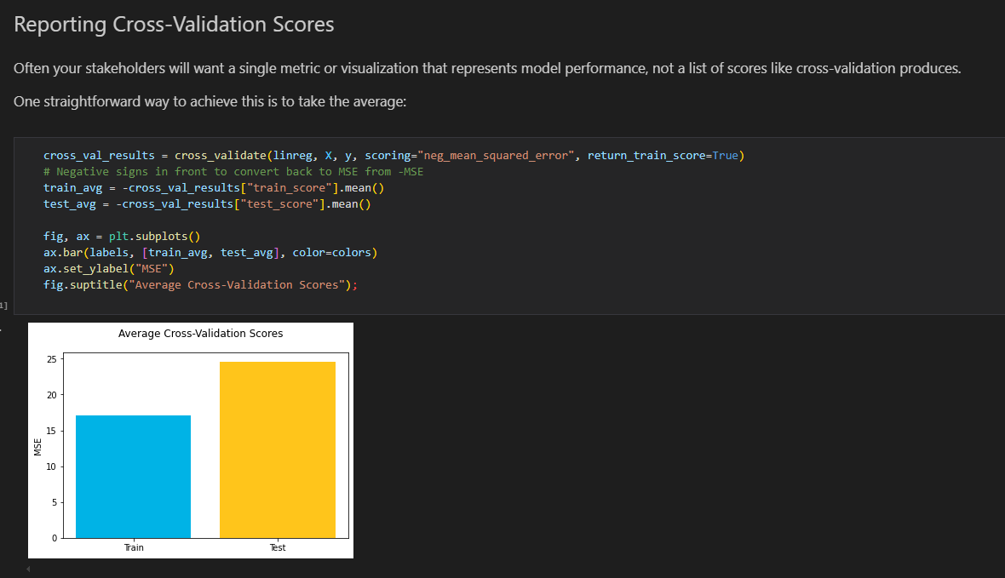

Another way, if you have enough folds to make it worthwhile, is to show the distribution of the train vs. test scores using a histogram or a box plot. *\*N.B.\**: The *\*x\**-axes are different scales, but the focus is on the different shapes of the respective distributions.

cross_val_results = cross_validate(linreg, X, y, cv=100, scoring="neg_mean_squared_error", return_train_score=True)

train_scores = -cross_val_results["train_score"]

test_scores = -cross_val_results["test_score"]

fig, (left, right) = plt.subplots(ncols=2, figsize=(10,5), sharey=True)

bins=25

left.hist(train_scores, label=labels[0], bins=bins, color=colors[0])

left.set_ylabel("Count")

left.set_xlabel("MSE")

right.hist(test_scores, label=labels[1], bins=bins, color=colors[1])

right.set_xlabel("MSE")

fig.suptitle("Cross-Validation Score Distribution")

fig.legend();

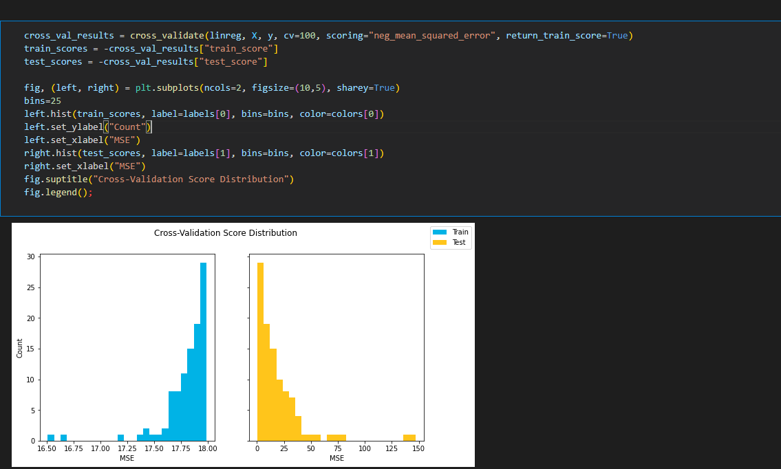

1. **Log Transform and hot encoding in one place**

import pandas as pd

import numpy as np

import matplotlib.pyplot as plt

%matplotlib inline

ames = pd.read_csv('data/ames.csv')

continuous = ['LotArea', '1stFlrSF', 'GrLivArea', 'SalePrice']

categoricals = ['BldgType', 'KitchenQual', 'SaleType', 'MSZoning', 'Street', 'Neighborhood']

ames_cont = ames[continuous]

# log features

log_names = [f'{column}_log' for column in ames_cont.columns]

ames_log = np.log(ames_cont)

ames_log.columns = log_names

# normalize (subract mean and divide by std)

def normalize(feature):

    return (feature - feature.mean()) / feature.std()

ames_log_norm = ames_log.apply(normalize)

# one hot encode categoricals

ames_ohe = pd.get_dummies(ames[categoricals], prefix=categoricals, drop_first=True)

preprocessed = pd.concat([ames_log_norm, ames_ohe], axis=1)

X = preprocessed.drop('SalePrice_log', axis=1)

y = preprocessed['SalePrice_log']

1. **Another example of one hot encoding**

ohe = OneHotEncoder(drop='first', sparse_output=False)

train_female = ohe.fit_transform(X_train[['SEX']]).flatten()

test_female = ohe.transform(X_test[['SEX']]).flatten()

1. **Ridge and Lasso Regression**

# Prepare data

from sklearn.linear_model import Lasso, Ridge, LinearRegression

poly = PolynomialFeatures(degree=6)

X_train_poly = poly.fit_transform(X_train)

X_test_poly = poly.transform(X_test)

X_train_transformed = scale.fit_transform(X_train_poly)

X_test_transformed = scale.transform(X_test_poly)

ridge = Ridge(alpha=0.5)

ridge.fit(X_train_transformed, y_train)

lasso = Lasso(alpha=0.5)

lasso.fit(X_train_transformed, y_train)

lin = LinearRegression()

lin.fit(X_train_transformed, y_train)

# Fit models

ridge.fit(X_train_transformed, y_train)

lasso.fit(X_train_transformed, y_train)

lin.fit(X_train_transformed, y_train)

# Generate predictions

y_h_ridge_train = ridge.predict(X_train_transformed)

y_h_ridge_test = ridge.predict(X_test_transformed)

y_h_lasso_train = lasso.predict(X_train_transformed)

y_h_lasso_test = lasso.predict(X_test_transformed)

y_h_lin_train = lin.predict(X_train_transformed)

y_h_lin_test = lin.predict(X_test_transformed)

# Display results

print('Train Error Polynomial Ridge Model', mean_squared_error(y_train, y_h_ridge_train))

print('Test Error Polynomial Ridge Model', mean_squared_error(y_test, y_h_ridge_test))

print('\n')

print('Train Error Polynomial Lasso Model', mean_squared_error(y_train, y_h_lasso_train))

print('Test Error Polynomial Lasso Model', mean_squared_error(y_test, y_h_lasso_test))

print('\n')

print('Train Error Unpenalized Polynomial Model', mean_squared_error(y_train, y_h_lin_train))

print('Test Error Unpenalized Polynomial Model', mean_squared_error(y_test, y_h_lin_test))

print('\n')

print('Polynomial Ridge Parameter Coefficients:', len(ridge.coef_[ridge.coef_ != 0]),

      'non-zero coefficient(s) and', len(ridge.coef_[ridge.coef_ == 0]), 'zeroed-out coefficient(s)')

print('Polynomial Lasso Parameter Coefficients:',  len(lasso.coef_[lasso.coef_ != 0]),

      'non-zero coefficient(s) and', len(lasso.coef_[lasso.coef_ == 0]), 'zeroed-out coefficient(s)')

print('Polynomial Model Parameter Coefficients:',  len(lin.coef_[lin.coef_ != 0]),

      'non-zero coefficient(s) and', len(lin.coef_[lin.coef_ == 0]), 'zeroed-out coefficient(s)')

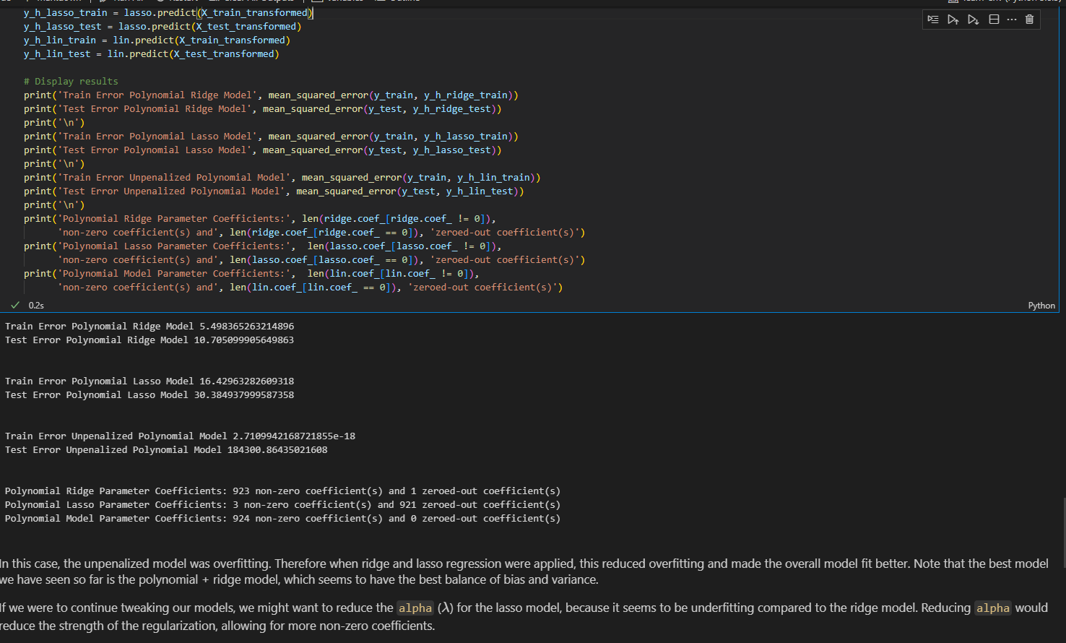

If we were to continue tweaking our models, we might want to reduce the alpha for the lasso model, because it seems to be underfitting compared to the ridge model. Reducing alpha would reduce the strength of the regularization, allowing for more non-zero coefficients.

1. **Getting r squared**

print('Training r^2:', linreg.score(X_train_preprocessed, y_train))

print('Test r^2:    ', linreg.score(X_test_preprocessed, y_test))

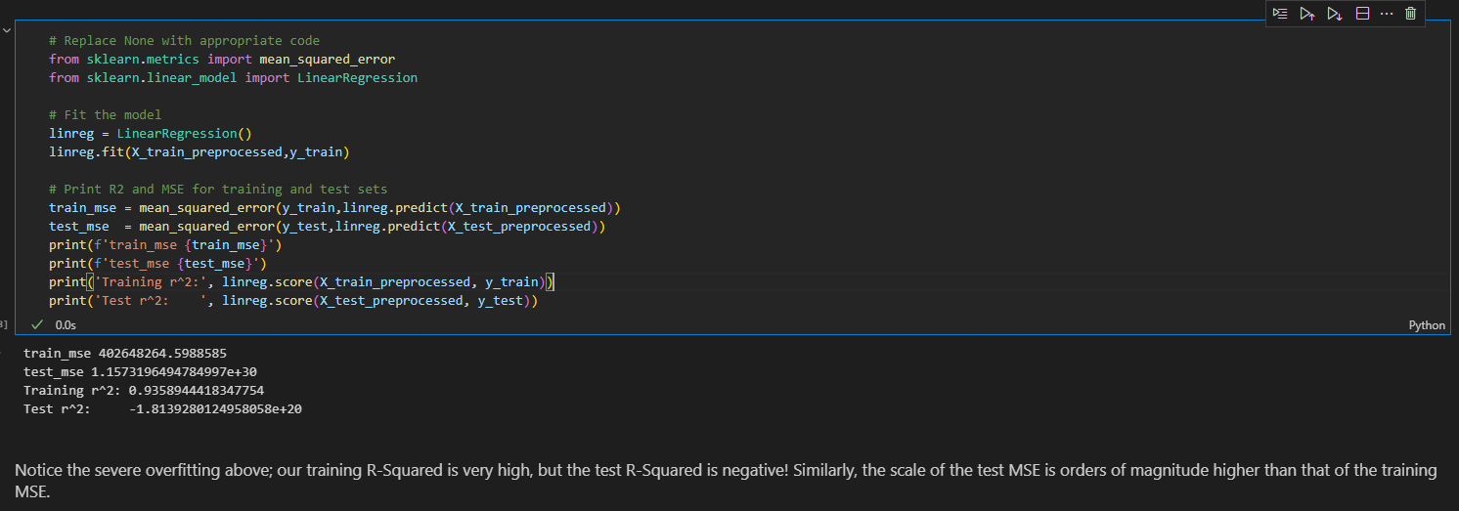

1. **Scale and add back to data frame(df) for modelling**

target = df['Y']

features = df.drop(columns='Y')

# Split the data

X_train, X_test, y_train, y_test = train_test_split(features, target, random_state=20, test_size=0.2)

# Create dummy variable for sex

ohe = OneHotEncoder(drop='first', sparse_output=False)

train_female = ohe.fit_transform(X_train[['SEX']]).flatten()

test_female = ohe.transform(X_test[['SEX']]).flatten()

# Initialize the scaler

scaler = StandardScaler()

# Scale every feature except the binary column - female

transformed_training_features = scaler.fit_transform(X_train.iloc[:,:-1])

transformed_testing_features = scaler.transform(X_test.iloc[:,:-1])

# Convert the scaled features into a DataFrame

X_train_transformed = pd.DataFrame(scaler.transform(X_train.iloc[:,:-1]),

                                   columns=X_train.columns[:-1],

                                   index=X_train.index)

X_test_transformed = pd.DataFrame(scaler.transform(X_test.iloc[:,:-1]),

                                  columns=X_train.columns[:-1],

                                  index=X_test.index)

# Add binary column back in

X_train_transformed['female'] = train_female

X_test_transformed['female'] = test_female

X_train_transformed

poly = PolynomialFeatures(degree=2, interaction_only=False, include_bias=False)

X_poly_train = pd.DataFrame(poly.fit_transform(X_train_transformed),

                            columns=poly.get_feature_names_out(X_train_transformed.columns))

X_poly_test = pd.DataFrame(poly.transform(X_test_transformed),

                           columns=poly.get_feature_names_out(X_test_transformed.columns))

X_poly_train.head()

1. **Logistic Regression using statsmodels**

relevant_columns = ['Pclass', 'Age', 'SibSp', 'Fare', 'Sex', 'Embarked', 'Survived']

dummy_dataframe = pd.get_dummies(df[relevant_columns],drop_first=True,dtype=float)

y = dummy_dataframe['Survived']

X = dummy_dataframe.drop('Survived',axis=1)

import statsmodels.api as sm

# Create intercept term required for sm.Logit, see documentation for more information

X = sm.add_constant(X)

# Fit model

logit_model = sm.Logit(y, X)

# Get results of the fit

result = logit_model.fit()

**Get parameter estimates**

**np.exp(result.params)**

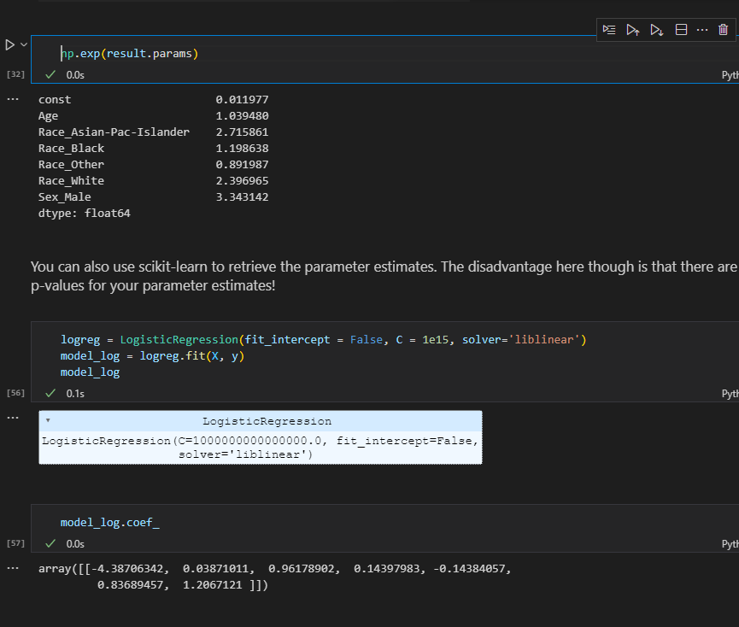

1. **Logistic Regression using scikit learn**

from sklearn.linear_model import LogisticRegression

logreg = LogisticRegression(fit_intercept=False, C=1e12, solver='liblinear')

model_log = logreg.fit(X_train_full, y_train)

model_log

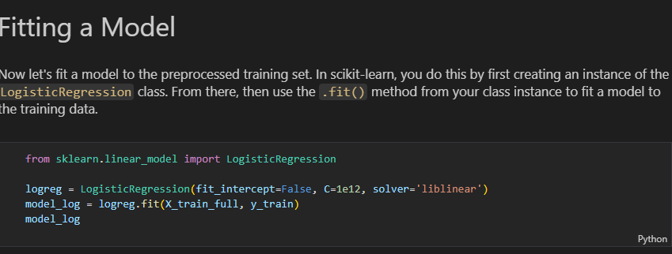

**MODEL EVALUATION**

**Train data**

y_hat_train = logreg.predict(X_train_full)

train_residuals = np.abs(y_train - y_hat_train)

print(pd.Series(train_residuals, name="Residuals (counts)").value_counts())

print()

print(pd.Series(train_residuals, name="Residuals (proportions)").value_counts(normalize=True))

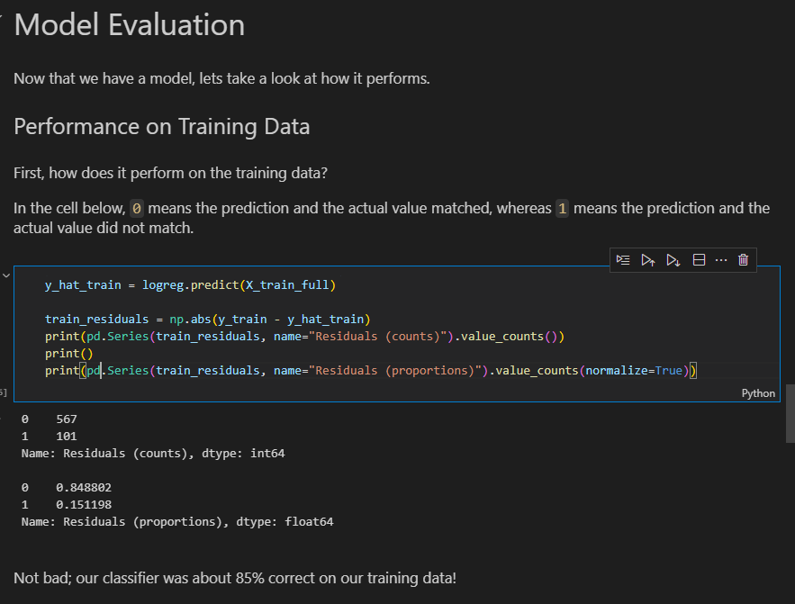

**Test Data**

# Filling in missing categorical data

X_test_fill_na = X_test.copy()

X_test_fill_na.fillna({"Cabin":"cabin_missing", "Embarked":"embarked_missing"}, inplace=True)

# Filling in missing numeric data

test_age_imputed = pd.DataFrame(

    imputer.transform(X_test_fill_na[["Age"]]),

    index=X_test_fill_na.index,

    columns=["Age"]

)

X_test_fill_na["Age"] = test_age_imputed

# Handling categorical data

X_test_categorical = X_test_fill_na[categorical_features].copy()

X_test_ohe = pd.DataFrame(

    ohe.transform(X_test_categorical),

    index=X_test_categorical.index,

    columns=np.hstack(ohe.categories_)

)

# Normalization

X_test_numeric = X_test_fill_na[numeric_features].copy()

X_test_scaled = pd.DataFrame(

    scaler.transform(X_test_numeric),

    index=X_test_numeric.index,

    columns=X_test_numeric.columns

)

# Concatenating categorical and numeric data

X_test_full = pd.concat([X_test_scaled, X_test_ohe], axis=1)

X_test_full

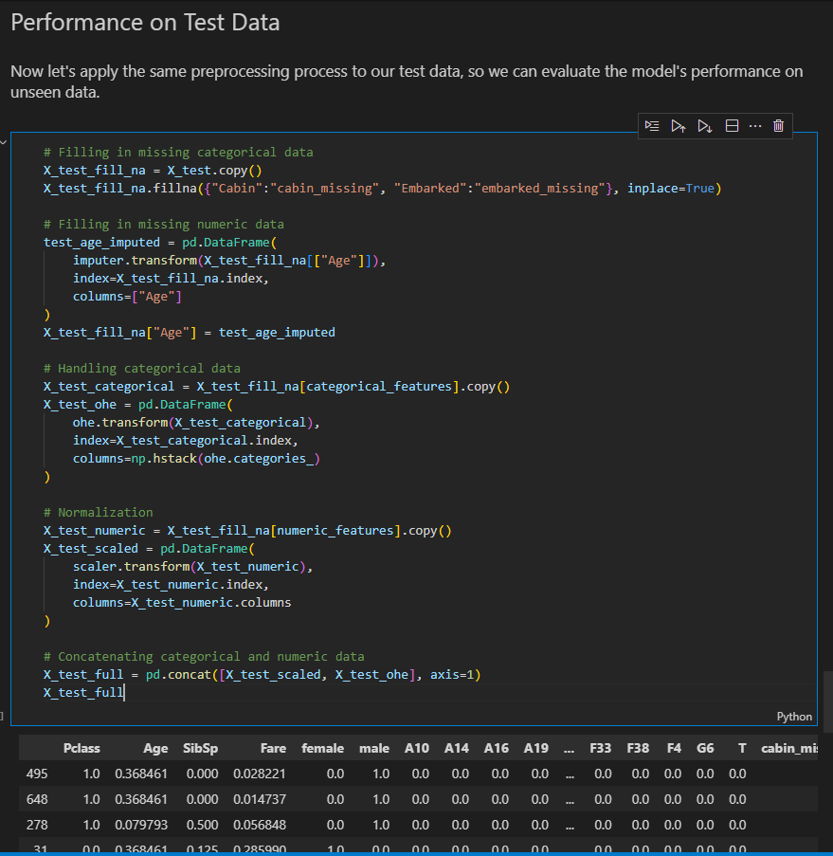

y_hat_test = logreg.predict(X_test_full)

test_residuals = np.abs(y_test - y_hat_test)

print(pd.Series(test_residuals, name="Residuals (counts)").value_counts())

print()

print(pd.Series(test_residuals, name="Residuals (proportions)").value_counts(normalize=True))

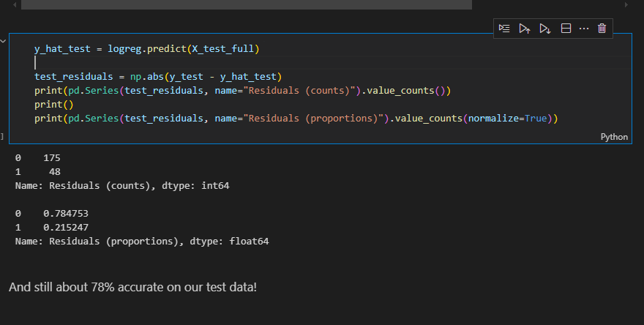

1. **Fill missing values for multiple columns**

X_train_fill_na = X_train.copy()

X_train_fill_na.fillna({"Cabin":"cabin_missing", "Embarked":"embarked_missing"}, inplace=True)

X_train_fill_na.isna().sum()

1. **Using Imputter to fill**

from sklearn.impute import SimpleImputer

imputer = SimpleImputer()

imputer.fit(X_train_fill_na[["Age"]])

age_imputed = pd.DataFrame(

    imputer.transform(X_train_fill_na[["Age"]]),

    # index is important to ensure we can concatenate with other columns

    index=X_train_fill_na.index,

    columns=["Age"]

)

X_train_fill_na["Age"] = age_imputed

1. X_train_fill_na.isna().sum()

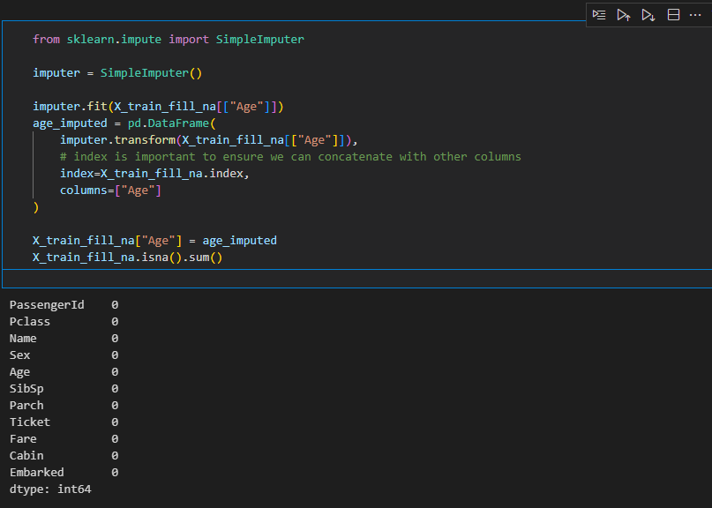

1. **Select categorical columns only**

X_train_categorical = X_train_fill_na.select_dtypes(exclude=["int64", "float64"]).copy()

X_train_categorical

1. **Scaling with MinMax scaler**

from sklearn.preprocessing import MinMaxScaler

scaler = MinMaxScaler()

scaler.fit(X_train_numeric)

X_train_scaled = pd.DataFrame(

    scaler.transform(X_train_numeric),

    # index is important to ensure we can concatenate with other columns

    index=X_train_numeric.index,

    columns=X_train_numeric.columns

)

X_train_scaled

1. **Confusion Matrix**

X = df.drop(columns=["Survived"])

y = df["Survived"]

X_encoded = pd.get_dummies(X,columns=["Sex"],drop_first=True,dtype=int)

model =  LogisticRegression()

model.fit(X_encoded_train,y_train)

y_pred = model.predict(X_encoded_test)

from  sklearn.metrics import confusion_matrix

cfn = confusion_matrix(y_true=y_test,y_pred=y_pred)

sns.heatmap(cfn,annot=True)

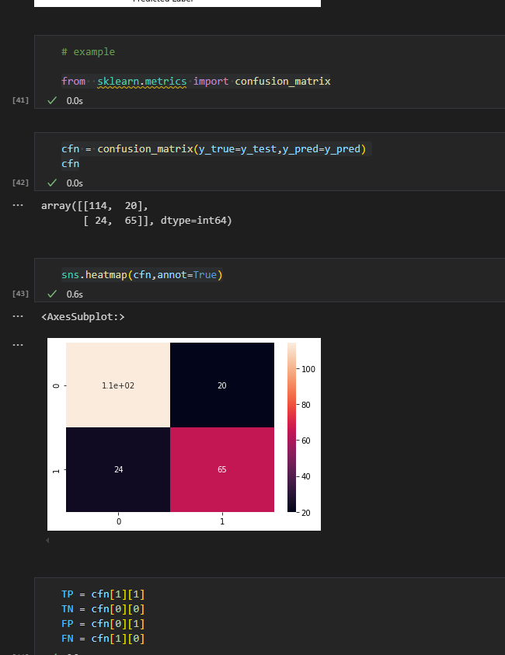

from sklearn.metrics import confusion_matrix

example_labels = [0, 1, 1, 1, 0, 1, 0, 1, 0, 0, 1]

example_preds  = [0, 1, 0, 1, 0, 0, 1, 1, 1, 1, 1]

cf = confusion_matrix(example_labels, example_preds)

cf

D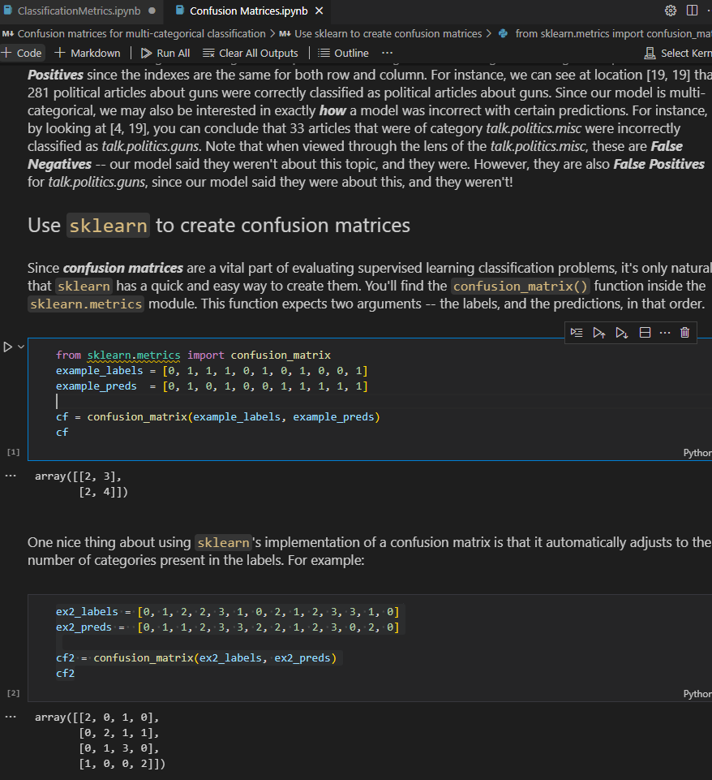

1. **Display confusion matrix**

# Import plot_confusion_matrix

from sklearn.metrics import ConfusionMatrixDisplay

# Visualize your confusion matrix

disp = ConfusionMatrixDisplay(confusion_matrix=cnf_matrix, display_labels=model_log.classes_)

disp.plot(cmap=plt.cm.Blues);

